

Use Case Specification: Supervisor eCL Notification
For

eCoaching Log

Change History Log

Date | Version | Description | Author
08/18/2014 | 1.0 | Initial Document | Doug Stearns
09/09/2014 | 1.1 | Updates from review and phase 2 development | Doug Stearns

Table of Contents

1. Brief Description 5
2. Participating Actors 5
2.1 Primary 5
2.2 Secondary 5
3. Basic Flow of Events 6
3.1 System generates eCoaching eMail notification. 6
3.2 Employee (Supervisor) receives system generated eMail notification of eCoaching Log when coaching is Direct and is not a Customer Service Escalation and status is Pending Employee Review, then the eMail notification will use the following: 6
3.3 Employee (Supervisor) selects hyper link to eCoaching Log Dashboard. 6
3.4 Employee (Supervisor) selects appropriate eCoaching Log to review. 6
3.5 Employee (Supervisor) selects acknowledgement of the coaching opportunity (required). 6
3.6 Employee (Supervisor) enters desired comments (free form text up to 3000 characters). 6
3.7 Employee (Supervisor) submits the acknowledgement. 6
3.8 Status of eCoaching Log becomes Completed. 6
4. Alternative Flows 7
4.1 Pending Manager Review. [Step 3.2] 7
4.2 Pending Sr. Manager Review. [Step 3.2] 7
4.3 Pending Sr. Manager Review. [Step 4.2.4] 8
4.4 Pending Sr. Manager Review. [Step 3.2] 8
4.5 Pending Sr. Manager Review. [Step 4.4.4] 8
4.6 Outlier Data Feed [Step 3.2] 8
5. Preconditions 9
5.1 eCoaching Log for Supervisor successfully submitted. 9
5.2 System generated eMail notification sent to appropriate parties. 9
5.3 eCoaching Log database populated with correct and current hierarchy information for Supervisors, Managers, Senior Managers. 9
6. Postconditions 9
6.1 eCoaching Log reviewed and acknowledged by Employee (Supervisor). 9
6.2 eCoaching Log reviewed and acknowledged by Manager. 9
6.3 eCoaching Log reviewed and acknowledged by Senior Manager. 9
7. Assumptions and Dependencies 9
7.1 Access to Supervisor module will be limited to those with the following job codes. 9
7.2 Basic from of eMail notification is as follows: 9
8. Business Rules 10
8.1 none 10
9. Technical Requirements 10
9.1 none 10
10. Activity Diagrams 11

Table of Figures
Figure 1 – Supervisor eCL Notification 11

Brief Description
eCoaching Log notifications and acknowledgment for Supervisors.

Participating Actors

Primary

Supervisors

Managers

Secondary

Senior Managers

Basic Flow of Events

System generates eCoaching eMail notification.

Employee (Supervisor) receives system generated eMail notification of eCoaching Log when coaching is Direct and is not a Customer Service Escalation and status is Pending Employee Review, then the eMail notification will use the following:

Subject:
eCL: Pending Employee Review (<EMPLOYEE NAME>))
Message:
A new eCoaching Log has been entered on your behalf. Please click on the link below to review and verify the coaching opportunity received on <DATE>.

Employee (Supervisor) selects hyper link to eCoaching Log Dashboard.

Employee (Supervisor) selects appropriate eCoaching Log to review.

Employee (Supervisor) selects acknowledgement of the coaching opportunity (required).

Employee (Supervisor) enters desired comments (free form text up to 3000 characters).

Employee (Supervisor) submits the acknowledgement.

Status of eCoaching Log becomes Completed.

Alternative Flows

Pending Manager Review. [Step 3.2]

Manger receives system generated eMail notification of eCoaching Log when coaching is Indirect and is not a Customer Service Escalation and status is Pending Manager Review then the eMail notification will use the following:
Subject:
eCL: Pending Manager Review (<EMPLOYEE NAME>)
Message:
A new eCoaching Log has been entered on behalf of <EMPLOYEE NAME> on <DATE> that requires your action. Please click on the link below to review the eCoaching log.

Manager selects the hyper link to eCoaching Log Dashboard.

Manager selects the appropriate eCoaching Log to review.

Manager selects or enters date of coaching (required).

Manager enters details of coaching session (required; free form text up to 3000 characters).

Manager submits eCoaching Log review.

Status of eCoaching Log becomes Pending Employee Review.

Pending Sr. Manager Review. [Step 3.2]

Senior Manager receives system generated eMail notification of eCoaching Log when coaching is Direct and is a Customer Service Escalation and status is Pending Sr. Manager Review then the eMail notification will use the following:
Subject:
eCL: Pending Sr. Manager Review (<EMPLOYEE NAME>)
Messge:
A new eCoaching Log has been entered and requires your action. Please click on the link below to review and verify that the eCL entered on <DATE > for <EMPLOYEE NAME> is a valid Customer Service Escalation (CSE). Further directions are provided on the form.

Senior Manager selects the hyper link to eCoaching Log Dashboard.

Senior Manager selects the appropriate eCoaching Log to review.

Senior Manager selects Yes to confirm it is a Customer Service Escalation (required).

Senior Manager selects or enters date coached (required).

Senior Manager enters coaching detail (required; free form text up to 3000 characters).

Senior Manager submits eCoaching Log review.

Status of eCoaching Log becomes Pending Manager Review.

Pending Sr. Manager Review. [Step 4.2.4]

Senior Manager selects No to confirm it is not a Customer Service Escalation (required).

Senior Manager selects or enters date reviewed (required).

Senior Manager enters reason not a Customer Service Escalation (required; free form text up to 3000 characters).

Continue with step 4.2.7 above.

Pending Sr. Manager Review. [Step 3.2]

Senior Manger receives system generated eMail notification of eCoaching Log when coaching is Indirect and is a Customer Service Escalation and status is Pending Sr. Manager Review then the eMail notification will use the following:
Subject:
eCL: Pending Sr, Manager Review (<EMPLOYEE NAME>)
Message:
A new eCoaching Log has been entered and requires your action. Please click on the link below to review and verify that the eCL entered on <DATE> for <EMPLOYEE NAME> is a valid Customer Service Escalation (CSE). Further directions are provided on the form.” form.

Senior Manager selects the hyper link to eCoaching Log Dashboard.

Senior Manager selects the appropriate eCoaching Log to review.

Senior Manager selects Yes to confirm it is a Customer Service Escalation (required).

Senior Manager selects or enters date coached (required).

Senior Manager enters coaching detail (required; free form text up to 3000 characters).

Senior Manager submits eCoaching Log review.

Status of eCoaching Log becomes Pending Manager Review.

Pending Sr. Manager Review. [Step 4.4.4]

Senior Manager selects No to confirm it is not a Customer Service Escalation (required).

Senior Manager selects or enters date reviewed (required).

Senior Manager enters reason not a Customer Service Escalation (required; free form text up to 3000 characters).

Continue with step 4.4.7 above.

Outlier Data Feed [Step 3.2]

There is no Outlier Data Feed at this time.

Preconditions

eCoaching Log for Supervisor successfully submitted.

System generated eMail notification sent to appropriate parties.

eCoaching Log database populated with correct and current hierarchy information for Supervisors, Managers, Senior Managers.

Postconditions

eCoaching Log reviewed and acknowledged by Employee (Supervisor).

eCoaching Log reviewed and acknowledged by Manager.

eCoaching Log reviewed and acknowledged by Senior Manager.

Assumptions and Dependencies

Access to Supervisor module will be limited to those with the following job codes.
Supervisors | WACS40, WFFA40, WISY13, WMPR40, WPPM11, WPPT40, WPSM11, WPSM12, WPSM13, WPSM14, WPSM15, WTTI02. WTTR12, WTTR40
Managers | WACS50, WBCO50, WFFA50, WMPR50, WPOP50, WPPM50, WPPT50, WTTR50
Sr. Managers | WACS60, WBCO70, WEEX90, WEEX91, WPOP60, WPPM60, WPPM70, WPPM80, WPPT60

Basic from of eMail notification is as follows:

To – [strto]
Subject – [strSubject]
** This is an automated email. Do not reply to this email. **
[strCtrMessage]
Please click here to open the coaching application and select the 'My Dashboard' tab to view the below form ID for details. [Link to Dashboard]
Form ID: [strFormID]
(Please do not respond to this automated notification)
Thank you,
eCoaching Log Team


Business Rules

none

Technical Requirements

none

Activity Diagrams
Below is the activity diagram for the use case that provides a visual depiction of the flow of events.

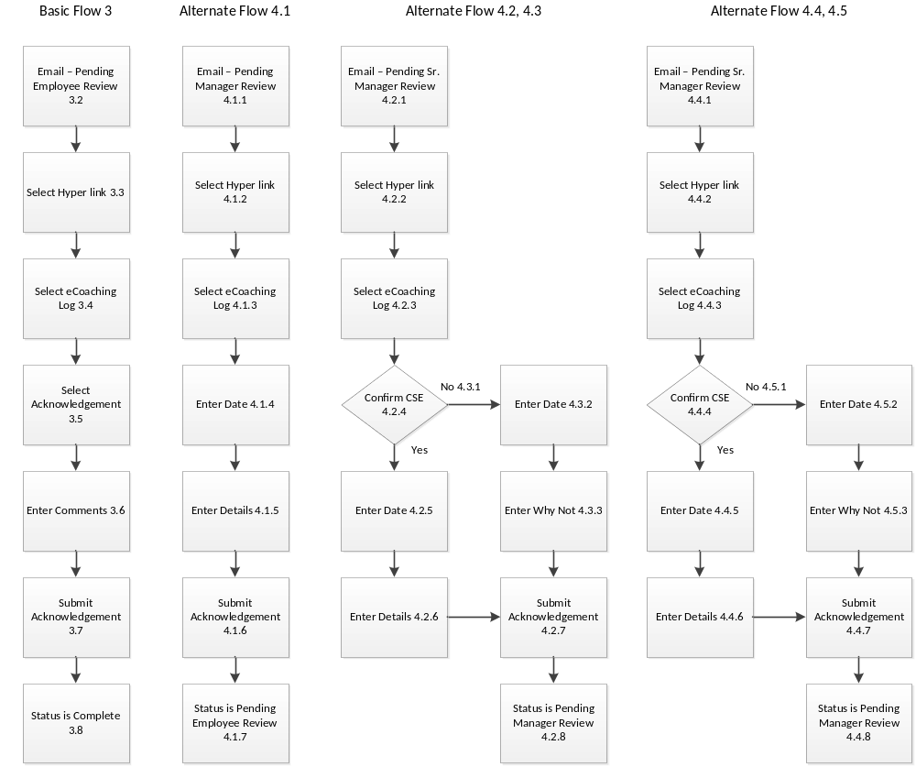

Figure 1 – Supervisor eCL Notification

